**Add A Picture To Your Gmail Signature In A Few Easy Steps**

1. In Gmail, click on your settings gear icon.

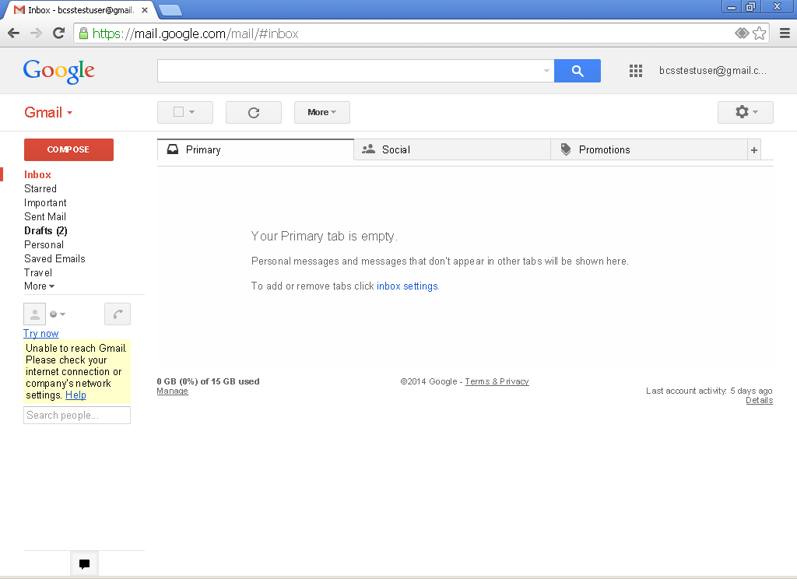

1. Click on “Settings”.

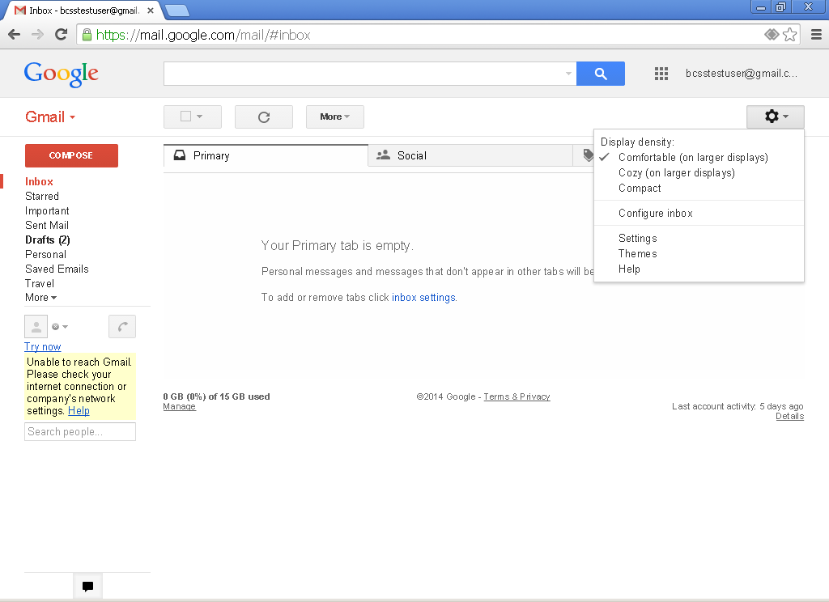

1. Scroll down to the signature area within settings. Then click on the “Add an Image” icon.

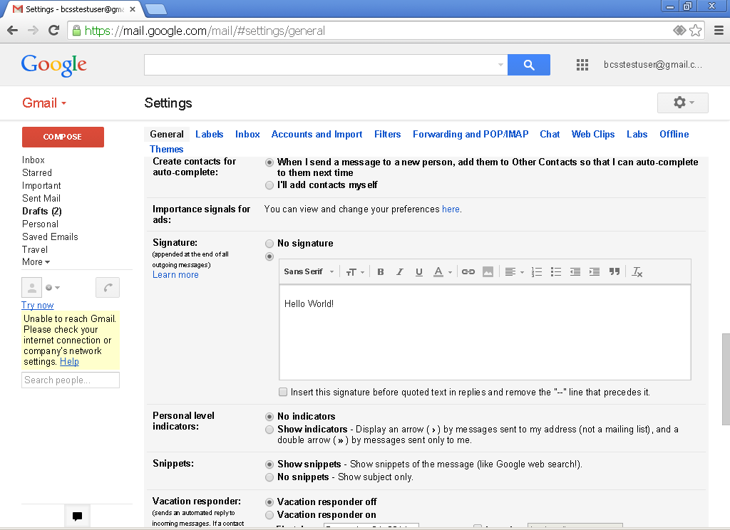

1. In the “Image URL” box, paste one of the following codes.

RD Tribute: <http://i213.photobucket.com/albums/cc256/adam_meador/email_photos/RD_logo_zpsc1f852a5.png>

Wolf Logo 1

<http://i213.photobucket.com/albums/cc256/adam_meador/email_photos/wolves_logo2_zps7ba70fb0.png>

Wolf Logo 2

<http://i213.photobucket.com/albums/cc256/adam_meador/email_photos/wolves_logo_zpsf0d7abd5.jpg>

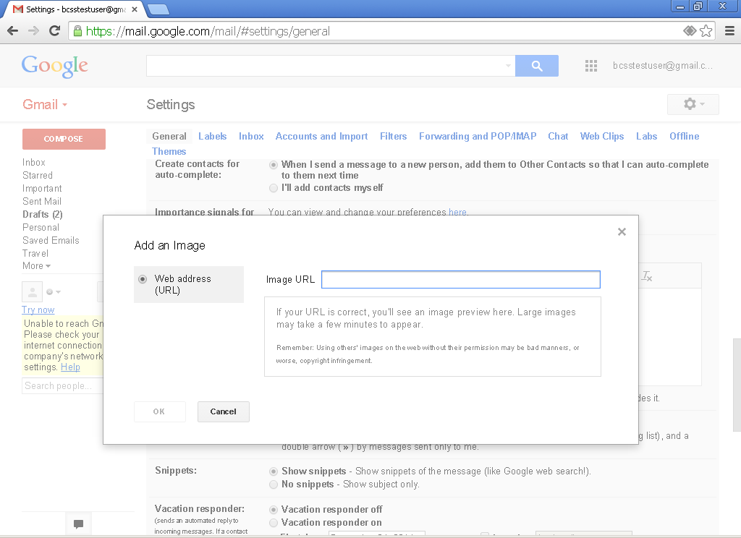

Then click “OK”.

5. Click on the image, this will give you the option to increase or decrease the size of the image.



6. When you are satisfied with your signature, scroll down and save your changes. Done!

